
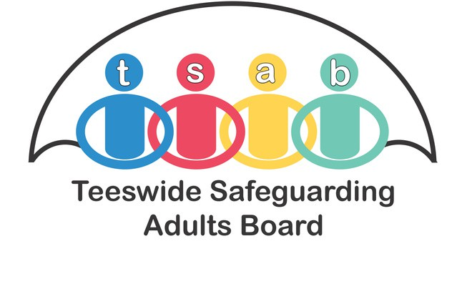
About Us
The Teeswide Safeguarding Adults Board is a statutory body working across the four local boroughs to effectively prevent and respond to adult abuse.

Adults in the Tees area with care and support needs can live safely, free from abuse and neglect.

My safeguarding contact is:

Produced by Durham Safeguarding Adults Partnership in conjunction with the North East Safeguarding Adults Networks

More Information :
Hartlepool Borough Council 01429 523 390
Middlesbrough Council 01642 065 070
Redcar and Cleveland Borough Council
01642 771 500
Stockton-on-Tees Borough Council 01642 527 764
Evenings and Weekends 01642 524 552

Online reporting

www. hartlepool.gov.uk www.middlesbrough.gov.uk www.redcar-cleveland.gov.uk www.stockton.gov.uk

Safeguarding Adult Enquiries

Safeguarding means protecting your right to live in safety, free from abuse and neglect.

What is a safeguarding enquiry?
A safeguarding enquiry is an action that local authorities take if you have care and support needs and when a report is made about abuse or neglect or the risk of it. You might need help to protect yourself.

Who might be involved?

Safeguarding enquiries mean we involve you, your representative, or someone acting on your behalf. It can also mean involving other agencies that might have contact with you. This might be social workers, GP’s and other health services, housing services, fire and rescue services, or the voluntary sector. It can also mean the police if there has been a crime.

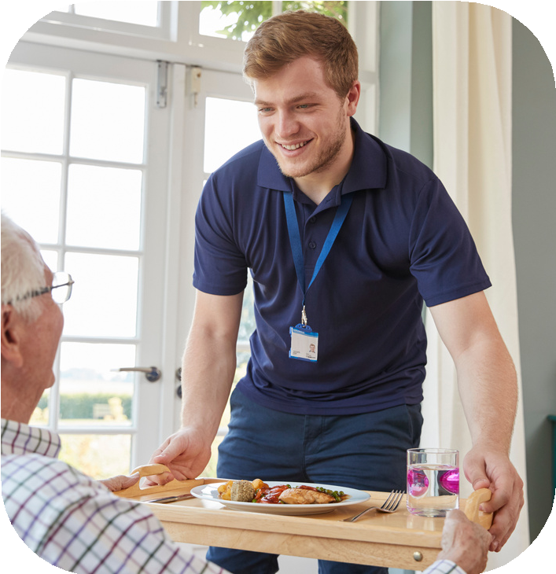

How does an enquiry take place?
An enquiry can take place as an informal conversation with you or with a person supporting you.

It may also be a more formal process.

It might be formal:
When there has been more than one report of abuse or when the concerns are serious.
When there might be concerns for other people at risk.
Or when there are concerns about people known to you, or about professionals, staff or volunteers involved in your care.

Will someone talk to me about the enquiry?
Yes, your views and wishes are important. You can tell us if you want our help, and what you would like to happen to help to keep you safe.

If you are supporting or representing someone you can tell us what you feel should happen on their behalf.

If there is no-one supporting the person, the local authority can seek advice from someone to act on their behalf. This is known as an ‘advocate’.

What happens next?
Working with you or your representative, and professionals we will work together to agree a plan to keep you safe.

This means reaching the best outcome for you, with you.

We will do this with your help or with the help of someone representing you.

