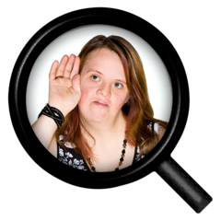

We want to hear from you to help us plan our work for the next year.  Please take a few minutes to fill in the survey below from your point of view – the form can be completed for someone else if the person is asked for their views. You will not be asked for your name or address, so if you have anything you’d like to ask about the survey please email: tsab.businessunit@stockton.gov.uk.

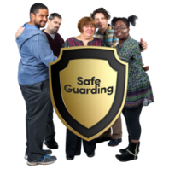

**Below are some of the words used in this questionnaire and what we mean by these:**

* **Safeguarding** means making sure you are safe from abuse and neglect, and are able to be independent and make choices



* **Abuse** is when someone hurts you or treats you badly. Abuse is always wrong and can happen to anyone. There are different types of abuse



* **Neglect** is when people who are supposed to help you don’t look after you properly, they may not give you enough food, not give you your medication or take you to the doctors if you are ill, they may not keep you safe.

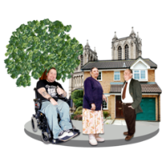



|  |  |
| --- | --- |
|  | Me8  I am a member of the general public |
|  | Assessment (P)  I am an adult who has used social care services |
|  | Care Worker 1  I am a carer |

**Tick one box only Please tell us who you are**

|  |  |
| --- | --- |
|  | Hartlepool Borough Council logo  Hartlepool |
|  | Logo, company name  Description automatically generated  Middlesbrough |
|  | Redcar & Cleveland |
|  | Stockton-On-Tees |

**Tick one box only Please tell us where you live**

|  |  |  |  |  |  |
| --- | --- | --- | --- | --- | --- |
| **Questions**  **Please tick one box for each question**  Checklist tick | **Strongly Agree**  Rating Outstanding | **Agree**  Rating Good | **Disagree**  CQC Requires Improvement | **Strongly Disagree**  Rating Inadequate | **Don’t**  **Know**  Dont know man2 |
| 1. I feel safe from abuse and neglect  Rights Safe |  |  |  |  |  |
| 2. I know how to report abuse and neglect |  |  |  |  |  |
| Meet whistleblower 13. I know how to get help and support if I am worried about abuse and neglect |  |  |  |  |  |

**4. I understand what these types of abuse mean (please tick all that apply):**

|  |  |  |
| --- | --- | --- |
| Discriminatory | Racism |  |
| Domestic | Winterbourne Bullies |  |
| Financial | Steal |  |
| Modern Slavery | Window look |  |
| Neglect | Ignored by Carer |  |



|  |  |  |
| --- | --- | --- |
| Organisational | Hospital 1 |  |
| Physical | Winterbourne abuse 5 |  |
| Psychological | Noise |  |
| Self-Neglect | Fed up |  |
| Sexual Abuse | Sexual harassment |  |
| Sexual Exploitation | Pornography |  |

|  |  |  |
| --- | --- | --- |
| **5.Please tick 3 things that The Teeswide Safeguarding Adults Board should do that are important to you** |  | Phases All |
| 1. Help people know how to protect themselves | Guidance |  |
| 1. Make it easier for people to report abuse and neglect | Tell friend |  |
| 1. Do more work to stop adult abuse and neglect from happening | Stop abuse sign 2 |  |
| 1. Make sure people are listened to and information is shared straight away with the organisations that help to protect them | Isolated 1Needs (P) |  |
| 1. Help the people who do risky things which make them and other people unsafe | Safety |  |
| 1. Check how services support people to be safe | Checking Support |  |
| 1. Work with other organisations to help people most at risk of abuse and neglect have a better life | Care Coordinator |  |

Please post completed surveys to: TSAB Business Unit, 1st Floor, Queensway House, Billingham, TS23 2NL to be received by Wednesday 31st January 2024. Or they can be scanned and emailed to [tsab.businessunit@stockton.gov.uk](mailto:tsab.businessunit@stockton.gov.uk).

The survey can also be completed online: <https://www.tsab.org.uk/campaigns-and-initiatives/annual-survey-2023-2024-general-public-easy-read/>

Thank you